**PRACTICAL NO : 03**

Name : Div

Roll No.:

**Title :** Creating an Application in SalesForce.com using Apex

programming Language

**STEPS TO CREATE AN APPLICATION :**

**Step No 1: Create new org:** [**https://developer.salesforce.com/signup**](https://developer.salesforce.com/signup)

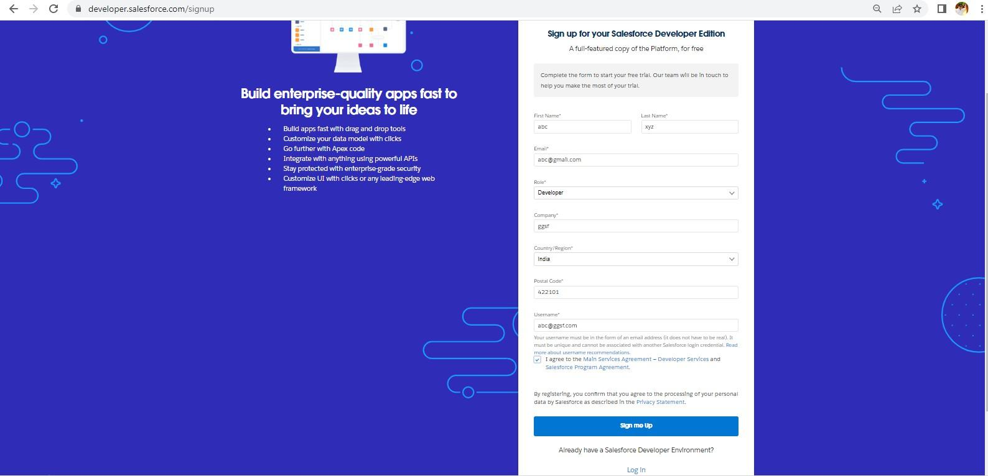

**Step No 2: After signup, loging using following URL** [**https://login.salesforce.com/**](https://login.salesforce.com/)

**Step No 3: Login Page (Enter your credential to login)**

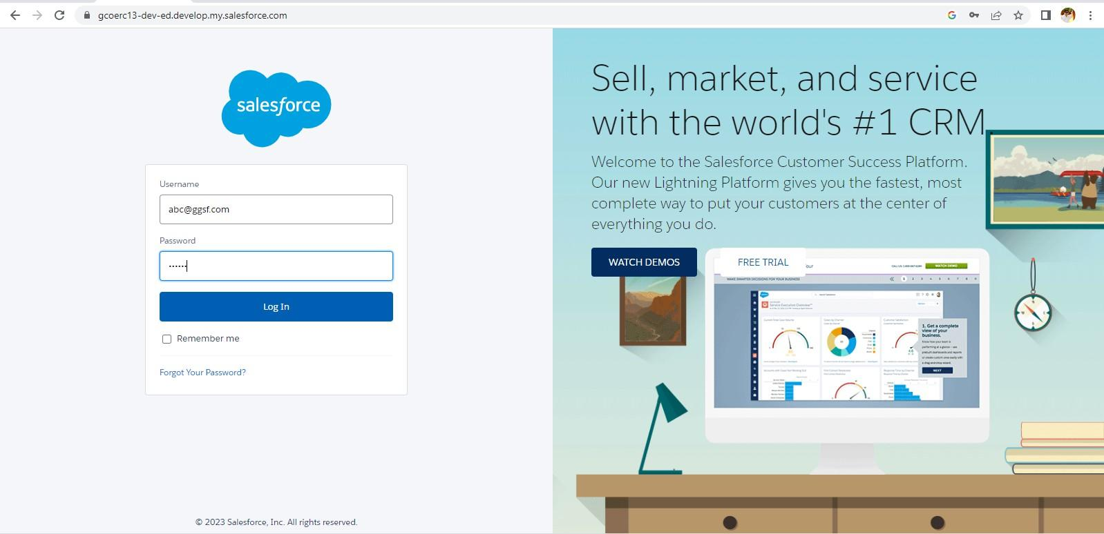

1. **Open Developer Console**
2. **File ---> New ---> Select Apex Class Type below mentioned code**

public class firstClass1 {

public static void Addition()

{

Integer a = 4; Integer b = 5; Integer c = a + b; Integer d = 4 + 5; Integer e = a + 5;

System.debug('Add = ' + c); System.debug('Add =' + d); System.debug('Add =' + e);

}

public static void Subtraction()

{

Integer a = 4; Integer b = 5; Integer c1 = a - b;

Integer d1 = b - a; Integer e1 = 4 - 5; Integer f1 = a - 5;

System.debug('Sub ='+ c1); System.debug('Sub =' + d1); System.debug('Sub =' + e1); System.debug('Sub =' + f1);

}

public static void Multi()

{

Integer a = 4;

Integer b = 5;

Integer c = a * b; Integer d = 4 * 5; Integer e = a * 5;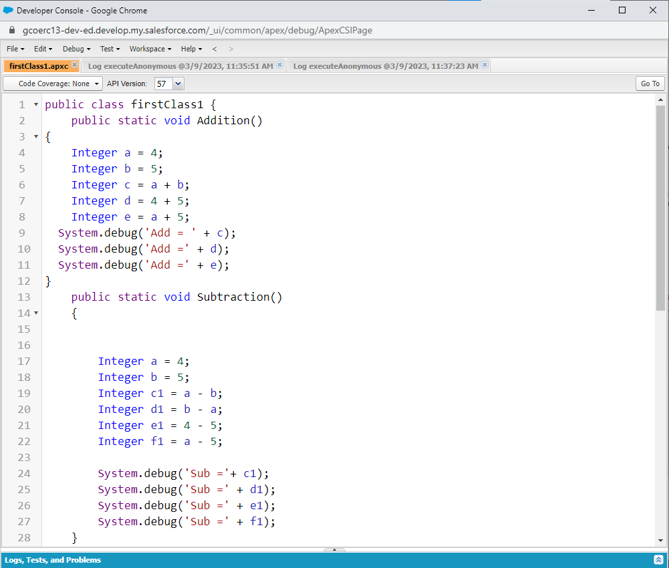

System.debug(c); System.debug(d); System.debug(e);

Integer f = -4; Integer g = a * f; System.debug(g);

}

public static void Div()

{

Integer a = 4;

Integer b = 5; Integer c = a / b; Integer d = 4 / 5; Integer e = a / 5;

System.debug(c); System.debug(d); System.debug(e);

}

}

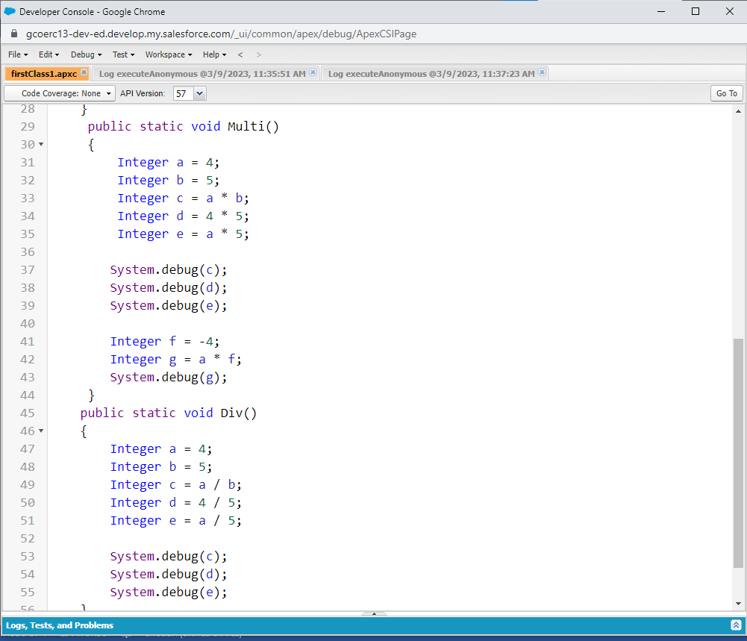

1. Click on Debug ---> Open Execute Acronymous Window
2. Type below code(Apex Code) firstClass1.Addition(); firstClass1.Subtaction(); firstClass1.Multi(); firstClass1.Div();
3. **Click on Open log then Execute code**

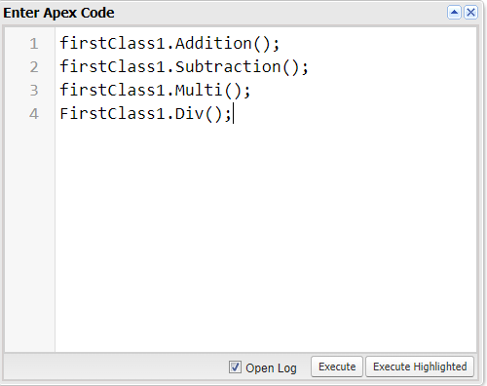

1. **Click on Debug only (You will get output)**

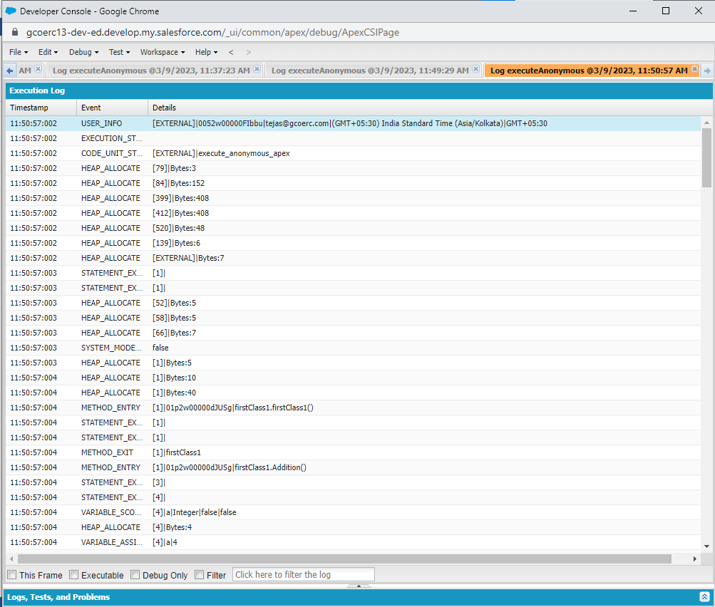

**Output :**